

**HTML Assignment -** Class 3

**Previous Class: Working with Lists, Tables, Links and Frames**

**Today Assignment: Making a table**

**Time: 15 minutes**

**Pass requirement: 4 / 10 points**

1. Create a table as following:

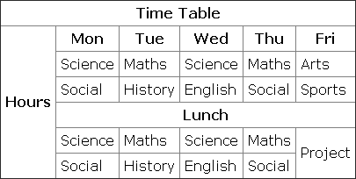

1. Make a table with correct row and column (3 points)
2. Use rowspan and colspan correctly (3 points)
3. Format text & border correctly (4 points)